027 Gulp -reload

Gulp Kata List – Blog Page

[Gulp Kata List on GitHub](https://github.com/robertdunaway/katas-gulp)

# Duration

10 minutes

# Brief

Add an automatic browser refresh to improve productivity.

### For More Information

BING/GOOGLE: “Gulp ”

Book: <http://www.amazon.com/Gulp-Quick-guide-getting-running/dp/151468960X>

# Instructions

Get tutorial folder or the entire katas-angular2 repo.

Open the [before/*.sln] file and execute the kata.

Feel free to execute this kata multiple times because repetition creates motor memory.

# Github

* Before (start kata with this)
  + https://github.com/robertdunaway/katas-gulp/tree/master/027%20Gulp%20-%20reload/before
* After
  + https://github.com/robertdunaway/katas-gulp/tree/master/027%20Gulp%20-%20reload/after

# Kata

Using gulp-livereload configure Gulp to automatically reload the browser when an HTML or JavaScript file is changed.

We are starting off with a fully functional gulpfile.js. The only thing left to do is configure the browser reload.

NOTE: This is an Angular2 solution.

# Review

Add the required NPM packages.

npm install gulp-livereload --save-dev

Add the module reference.

, livereload = require('gulp-livereload')

Create the reload task.

gulp.task('reload', function () {

// Change the filepath, when you want to live reload a different page in your project.

livereload.reload("./index.min.html");

});

Add the livereload listener to the watch task.

gulp.task('watch', function () {

livereload.listen();

Install the Chrome plugin that makes livereload possible.

<https://chrome.google.com/webstore/detail/livereload/jnihajbhpnppcggbcgedagnkighmdlei?hl=en>

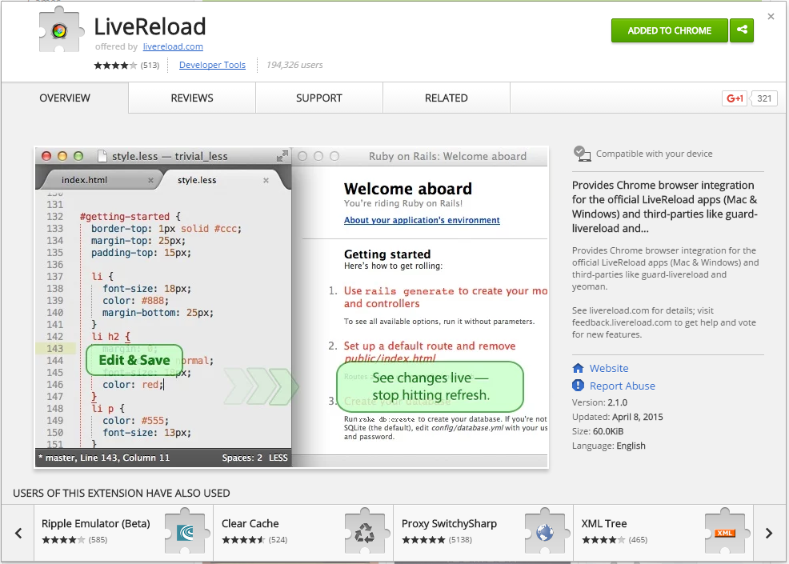

Add the reload task to each of the existing watch commands inside the watch task. Don’t add it to the copy-to-wwwroot watch task.

// ---------------------------------------------------------------

// Watching TypeScript files

// ---------------------------------------------------------------

gulp.watch(['wwwroot/**/*.ts', '!wwwroot/lib/**/*.*', '!wwwroot/css/**/*.*'], function () { runSequence('tscompile', 'reload'); });

// ---------------------------------------------------------------

// Watch - Execute linters

// ---------------------------------------------------------------

gulp.watch(['wwwroot/**/*.ts', '!wwwroot/lib/**/*.*', '!wwwroot/css/**/*.*'], function () { runSequence('tslint', 'reload'); });

// ---------------------------------------------------------------

// Watching HTML files

// ---------------------------------------------------------------

gulp.watch(['wwwroot/**/*.html', '!wwwroot/**/*.min.html', '!wwwroot/lib/**/*'], function () { runSequence('minifyhtml', 'reload'); });

Now run the site and in the Chrome browser press the “Enable LiveReload” button.

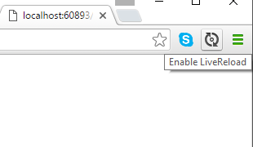

Make changes to the files in src/ and you’ll see the changes reflected in the browser.

# Next

Take a few minutes and imagine more examples.